Unemployment Insurance Data
August 6, 2021

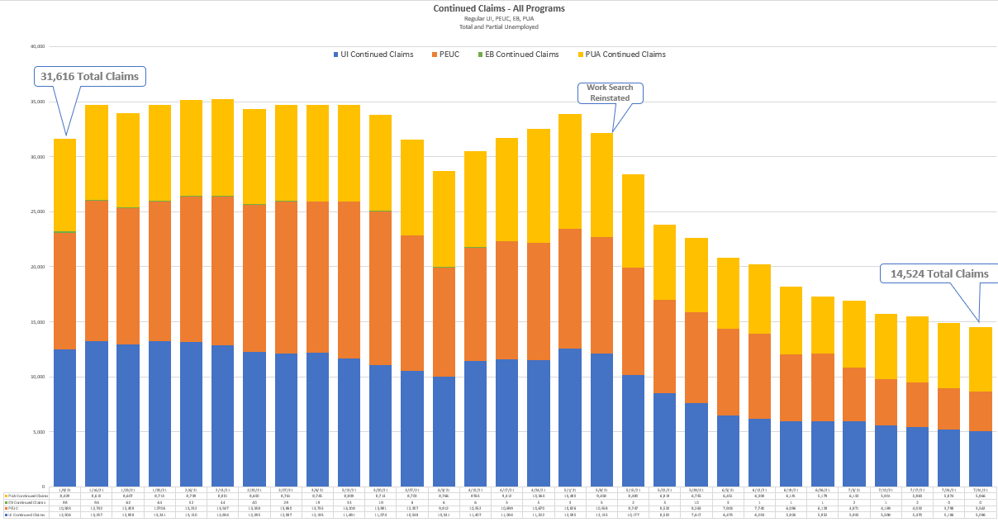

 |  |  | Continued Claims Filed
Week Ending |  | 6/12 |  | 6/19 | 6/26 | 7/3 | 7/10 | 7/17 | 7/24 | 7/31
Regular UI |  | 6,204 |  | 5,926 | 5,952 | 5,932 | 5,598 | 5,470 | 5,186 | 5,096
PEUC |  | 7,740 |  | 6,096 | 6,128 | 4,871 | 4,189 | 4,032 | 3,798 | 3,592
EB |  | 1 |  | 1 | 1 | 2 | 1 | 2 | 0 | 0
PUA |  | 6,308 |  | 6,191 | 5,179 | 6,132 | 5,931 | 5,963 | 5,874 | 5,866
Total |  | 20,253 |  | 18,214 | 17,260 | 16,937 | 15,719 | 15,467 | 14,858 | 14,524

Claims Payment Processing
Week Ending | All UI Claims Paid | All UI Payments | PUA Claims Paid* | PUA Payments | Total Payments Issued | Trust Fund Balance
June 12 | 12,927 | $4,430,957 | 5,728 | $3,579,399 | $8,010,356 | $215,576,010
June 19 | 11,031 | $3,775,760 | 6,350 | $3,942,907 | $7,718,667 | $215,057,592
July 26 | 9,919 | $3,348,250 | 5,799 | $3,517,371 | $6,865,621 | $213,882,287
July 3 | 9,574 | $3,268,451 | 5,913 | $2,381,925 | $5,650,376 | $213,691,628
July 10 | 8,583 | $2,879,927 | 5,264 | $3,218,450 | $6,098,377 | $212,485,981
July 17 | 8,239 | $2,919,439 | 5,702 | $3,531,504 | $6,450,943 | $211,650,866
July 24 | 7,929 | $2,831,059 | 5,793 | $3,569,649 | $6,400,708 | $210,918,130
July 31 | 7,584 | $2,733,666 | 5,458 | $3,362,615 | $6,096,281 | $212,895,057

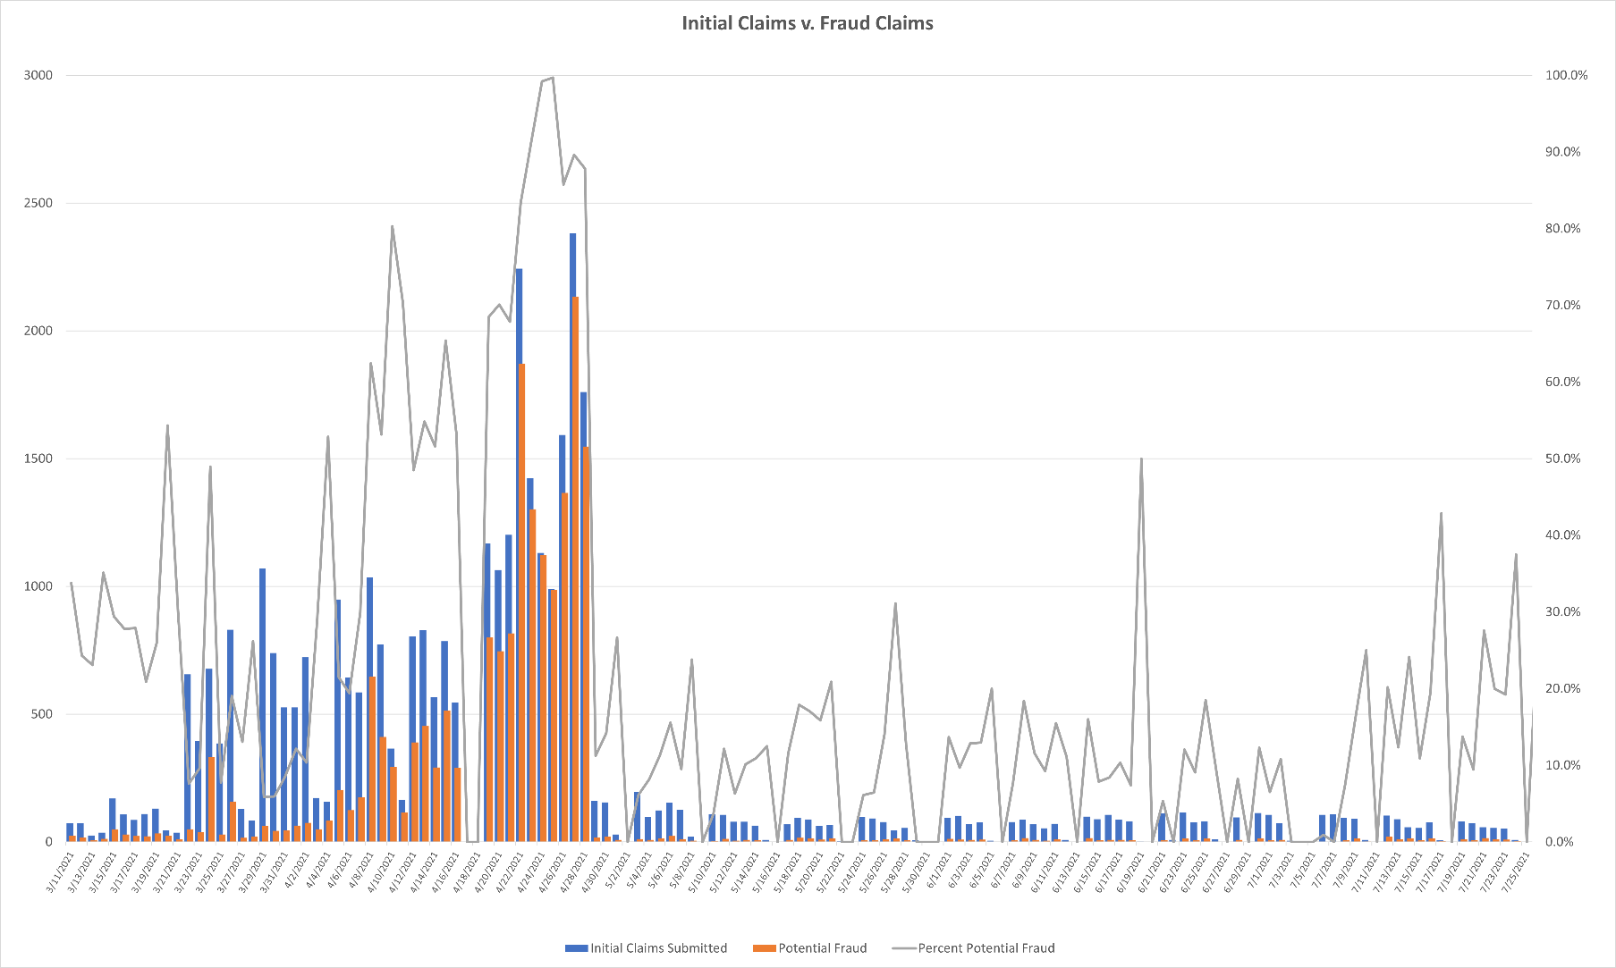

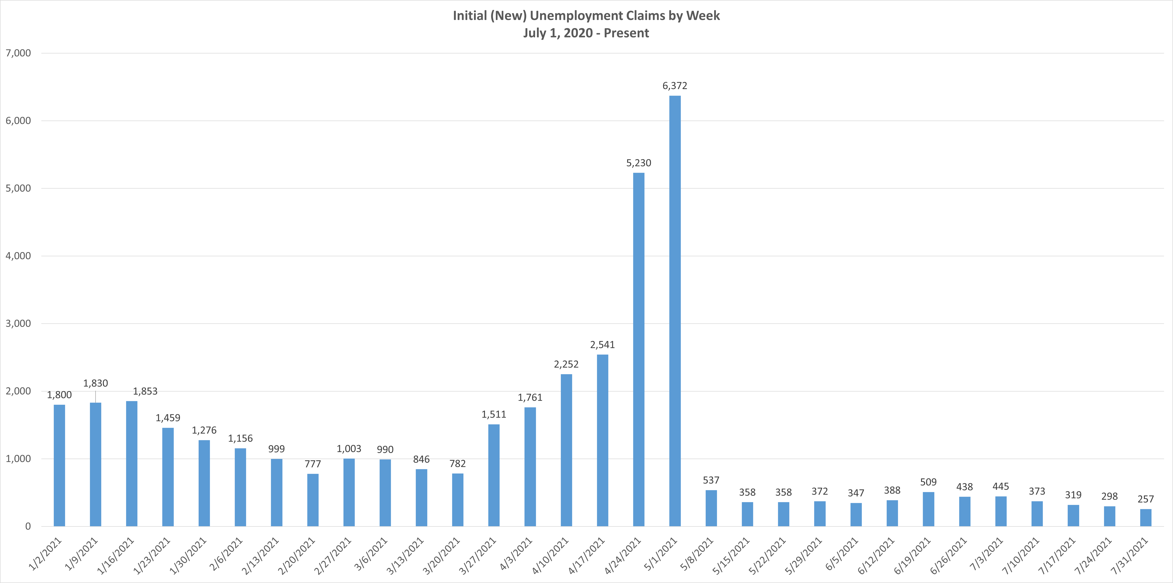

*the high number of initial claims can be attributed to the increased number of fraudulent claims submitted.

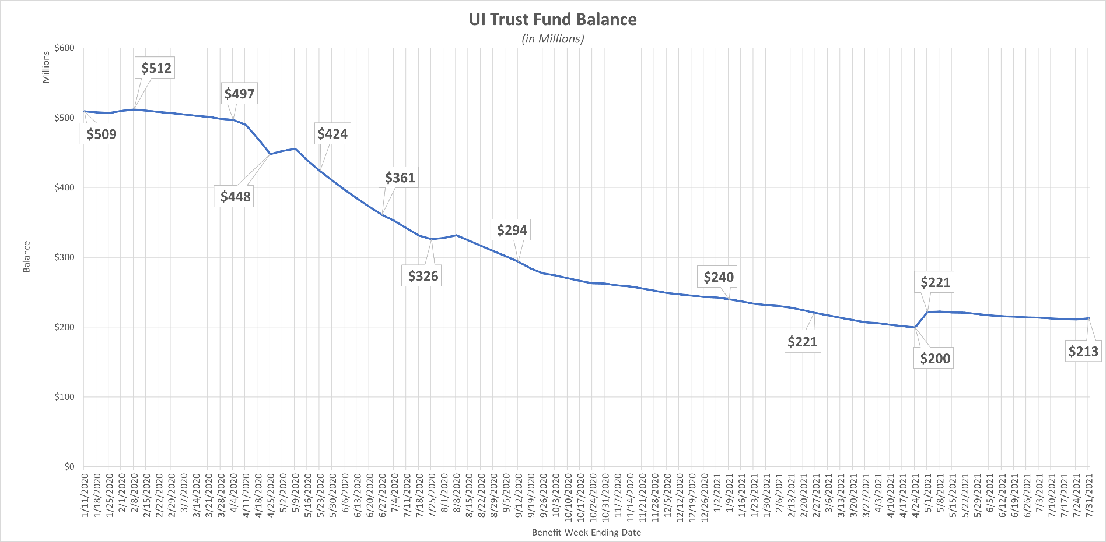

*increase in TF balance is a result of Q1 employer contributions

